IS-GRENOBLE 2024 EXTENDED ABSTRACT INSTRUCTIONS FOR AUTHORS USING MS-WORD
A. Author¹, B. Author² and C. Author^{1,2}
¹ Univ. Grenoble Alpes, CNRS, 3SR Lab., Grenoble, France
² Yamaguchi University, Fac. of Engineering, Ube, Japan
1. General
The authors are requested to submit extended two-page abstracts in the format described in sections 2-5 below. In general, the abstract should outline the area of research, the methodology, the basic assumptions and highlight the main results. A list of basic references is expected.
Extended abstracts selected for a poster or an oral presentation will be published in the collection "IS-Grenoble2024" of the open access plateform HAL (https://hal.science/IS-Grenoble 2024/). Abstracts selected for oral presentation will allow the submission of a full paper (4 pages), itself published in the Symposium collection.
The deadline of extended abstracts submission is December 20, 2023.
2. Paper size, margins and paper length
Please, use the standard A4 (210 × 297 mm) paper size. Allow 2 cm left and right margins and 2.5 cm top and bottom margins (use the typing area of 17 × 24.7 cm). Contributions longer than two pages, or those with poor quality of English, will not be included in the volume of abstracts.
3. Font size, spacing, title, headings
Times Roman fonts of 12 point size should be used throughout all the paper with single spacing between lines of text.
The title should be centered in all capital characters and bold face. Do not leave any additional space above the title. The title should be followed by authors’ names (bold-italic) and respective affiliations (italic). Leave 20 pt between the title and authors’ names and 30 pt space between the affiliation (institution, department, city, and country) and the beginning of the text. In order to save space, the affiliation should not include the full address of your institution.
The section headings (if used) should be left aligned with no indentation, set in bold face with extra space of 12 points above and 6 points below. The paragraphs should be left and right justified with 1-cm indentation of the first line. Page numbers must not be typed on the sheets.
4. Tables, figures and equations
Figures (see Figure 1), tables (Table 1) and their captions should be centered and numbered.

Paper size | Paper length | Font size | Line spacing
A4 (210x297) | 2 pages | 12 pt | single
Table 1. Basic format specifications.
Leave 12 points above and below the figure/table.
Displayed equations should be centered and the equation numbers (if necessary) should be placed in brackets at the right margin, e.g.:
$\begin{aligned}{\dot{σ}}_{ij}=D_{ijkl }{\dot{ϵ}}_{kl} \#\left(1\right)\end{aligned}$
Sufficient space (at least 6 pt) should be left above and below the equation.

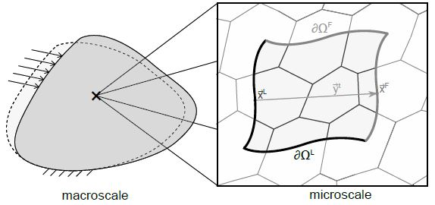
Figure 1. Example of a centred and numbered figure.
5. References
Any references should be placed at the end of the paper and referenced in the paper through the number in square brackets, e.g. [1]. The format of sample book and journal references is given below.

[1] Cosserat, E. & Cosserat, F. (1909). Théorie des corps déformables. A. Hermann et fils ed., Paris, France.
[2] Mindlin R.D. (1965). Second gradient of strain and surface-tension in linear elasticity. Int. J. Solids Struct., 1:417-438.

